C S Palmer was "Local Authority's Officer, Port Harcourt" - cover ex Francis Field 9 June 1944 to him, shown by Barbara 25 Feb. 2017. Mr Palmer had moved to Sudbury, Suffolk

10 May 2021 I Googled “Palmer Sudbury Nigeria” and found this on Ebay (£35 !!) dated June 1945

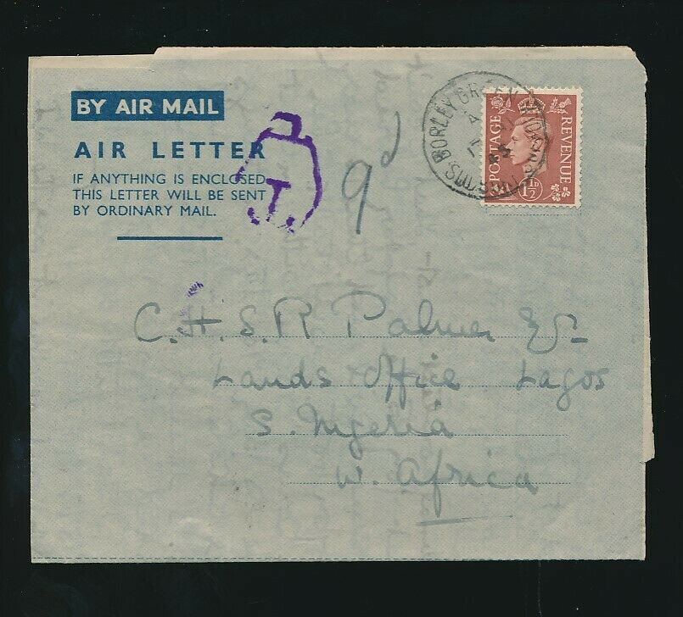

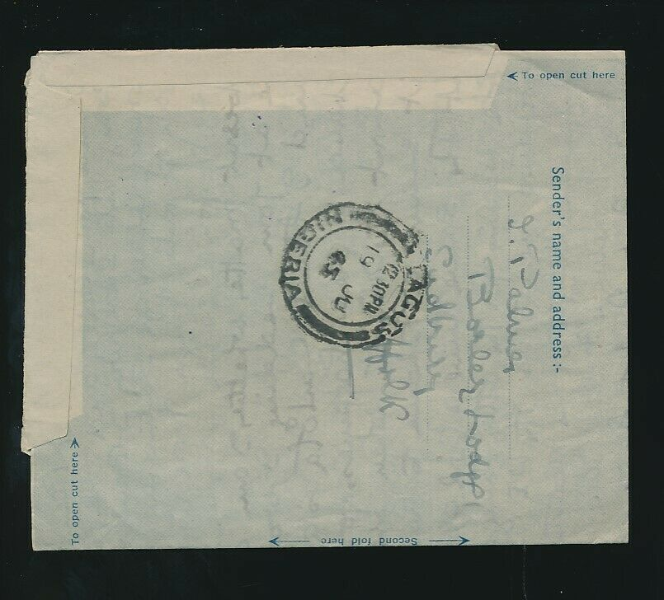

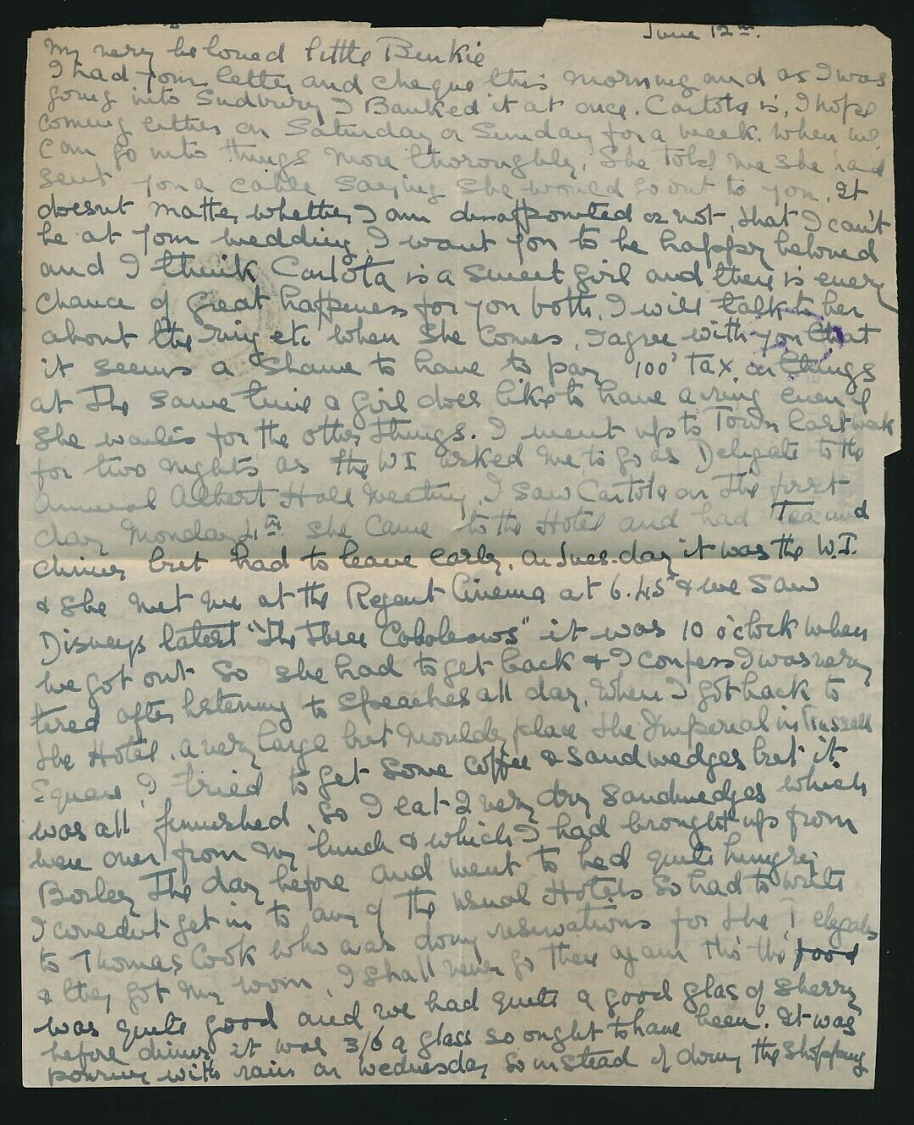

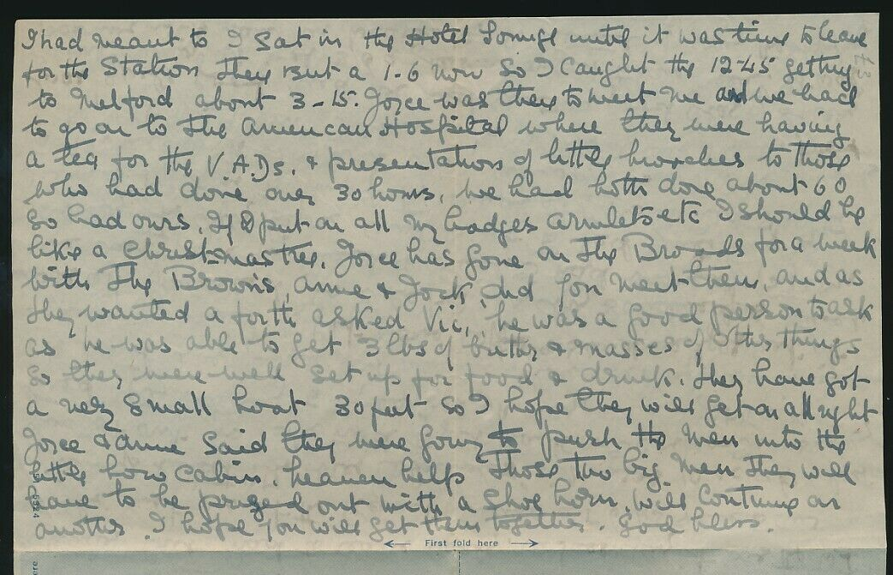

A Carlota Palmer died in February 2021 aged 99 in Budleigh Salterton

British Honduras Government Gazette July 7th 1962  
Fort George electoral register

